**Sample Paper**

**Paper: Probability and Statistics**

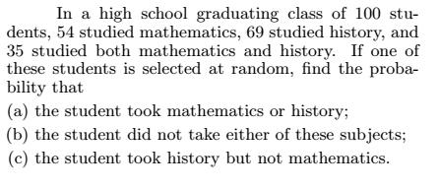Note: Attempt all questions. Use of mobile phone and other electronic accessories except Calculator are strictly prohibited in Examination Hall.

Q1:

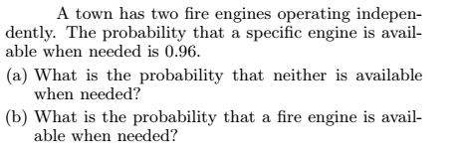Q3:

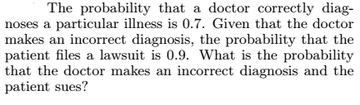

Q4:

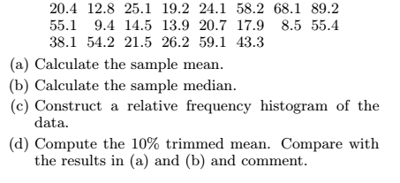Q5: The following data gives the percentages of the families that are in the upper income level